Sign In to Oracle Cloud Application

* URL: <https://cbsa.fa.em2.oraclecloud.com>

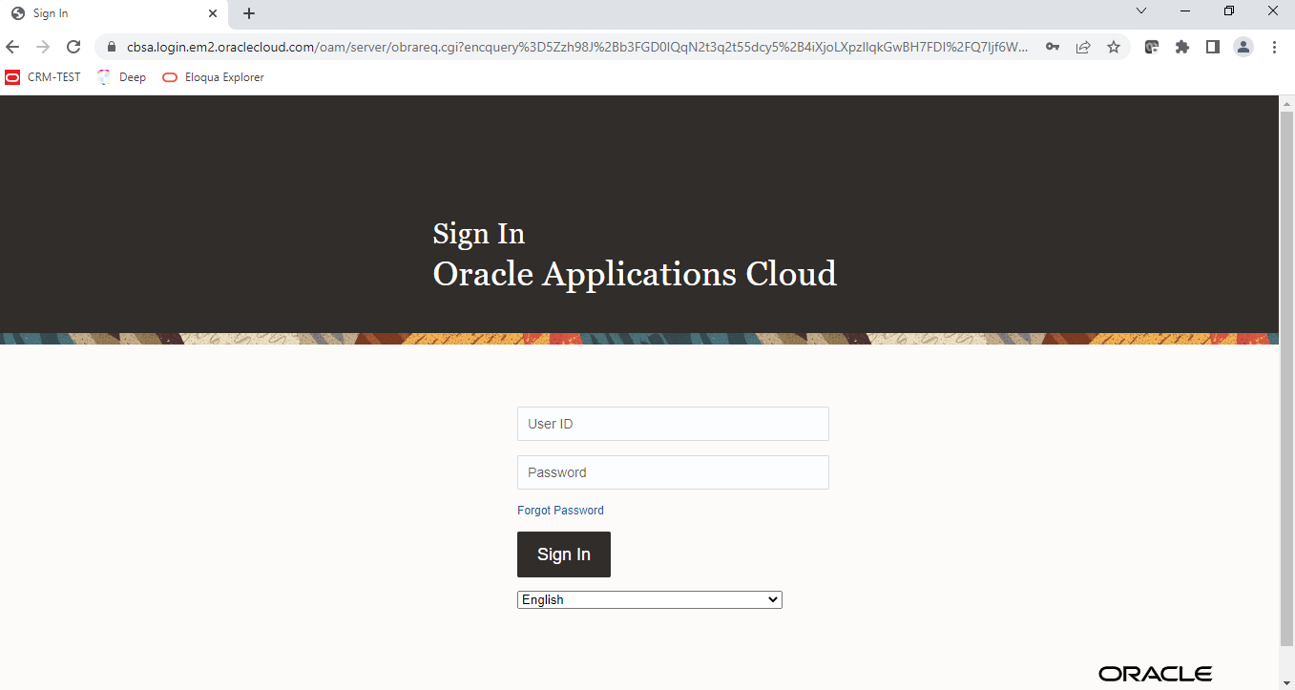

Enter User Id & Password

* Application Welcome page

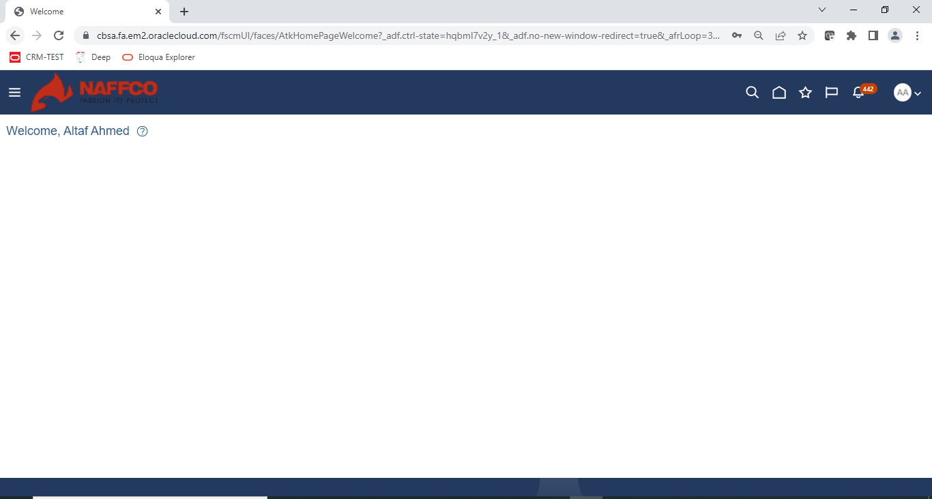

Click the home icon to redirect to user home page page

* Application user Homepage

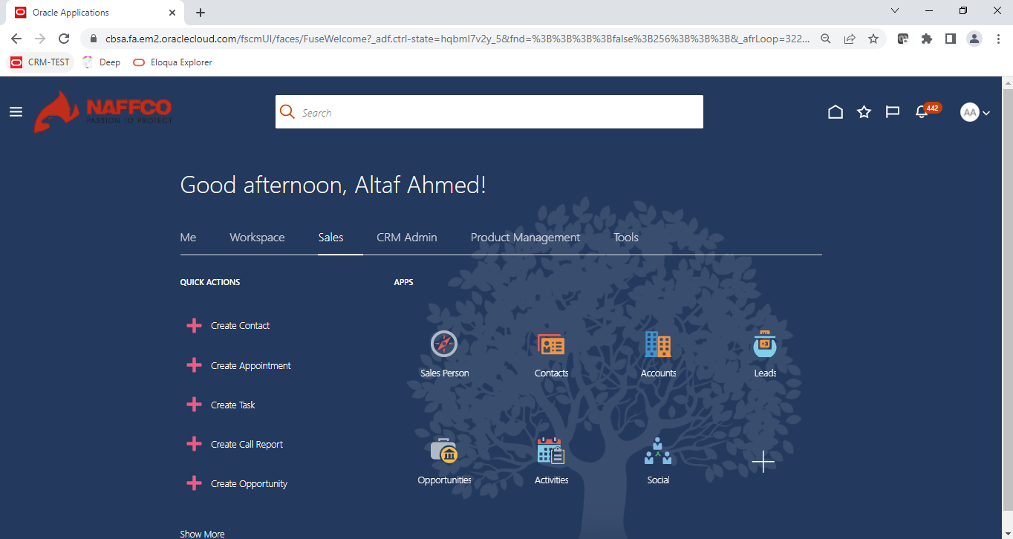

Click on sales tab to view the sales related tiles

* Sales Reports



Click on Sales Person tile to view sales Reports tiles

* Sales Person Quoted and Escalation Reports

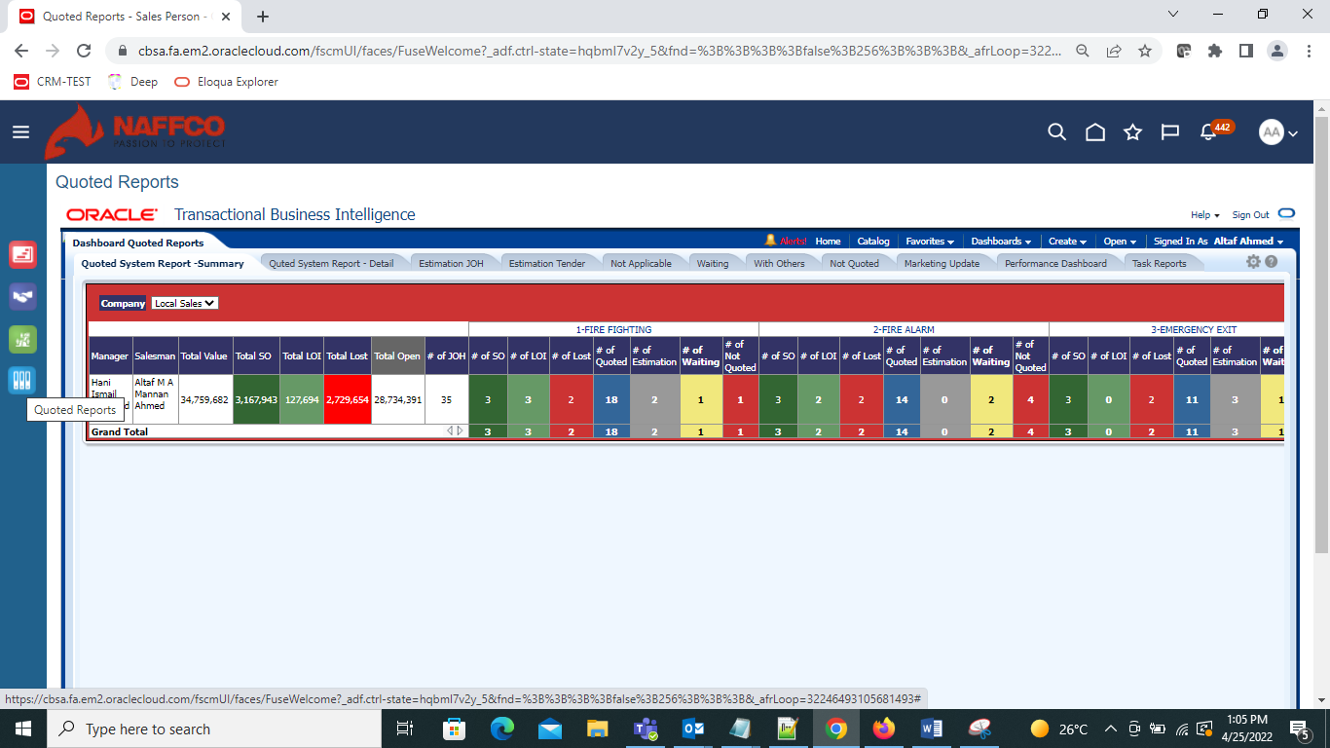

Click on Quoted Report tab

* Quoted Report Summary

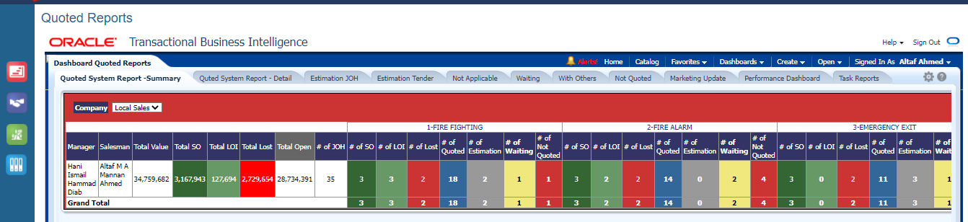

Opportunities with # Products based on Sub stage

* Quoted System Report Details as below

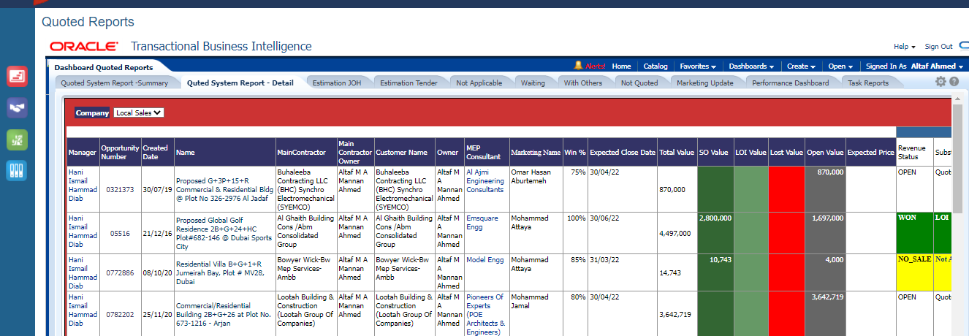

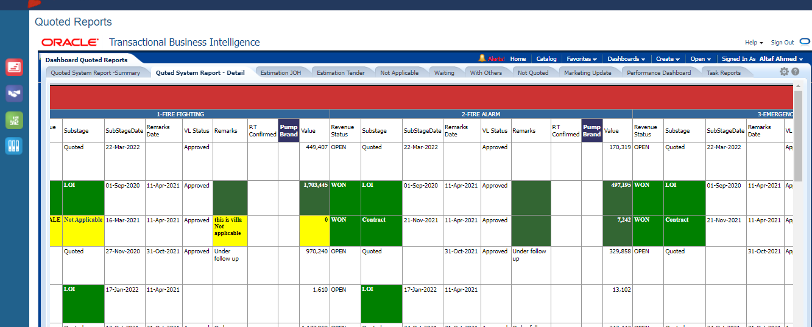

* Escalations: (refer below screen shot Navigation menu for each sub stage updates)
* Estimation JOH (Sub stage –Estimation More than 7 Days)
* Estimation Tender (Sub stage –Estimation More than 14 Days)
* Not Applicable (Sub stage -Not Applicable Systems)
* Waiting (Sub stage –Waiting Systems)
* With Others (Sub stage –With Others Systems)
* Not Quoted (Sub stage –Not Quoted Systems)

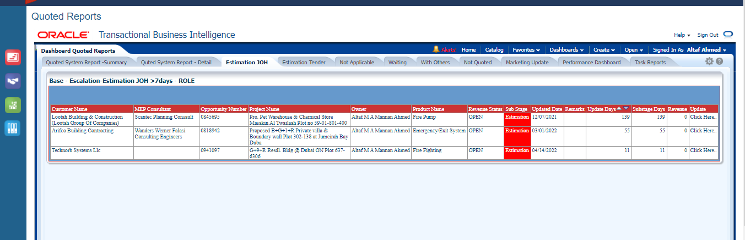

Click here. to update the sub stage

Sub stage Estimation Age more than 7 days

aThis will redirect to Opportunity Revenue to update sub stage

* Opportunty Revenue Detail Page

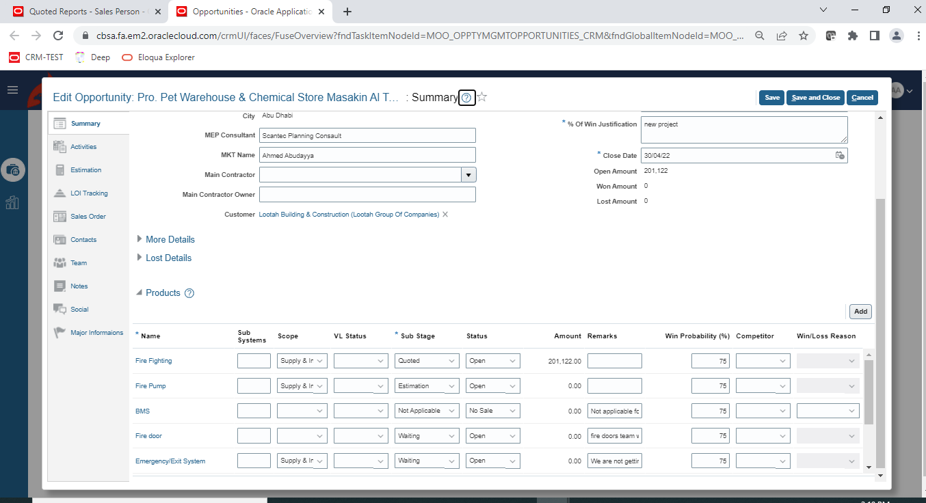

Click on Product Name Hyperlink to view the details page

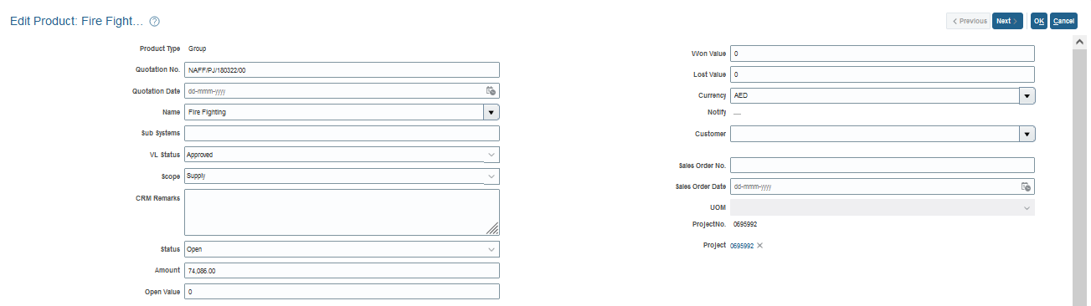

VL

Sub stage

Product

Revenue

Revenue Product details

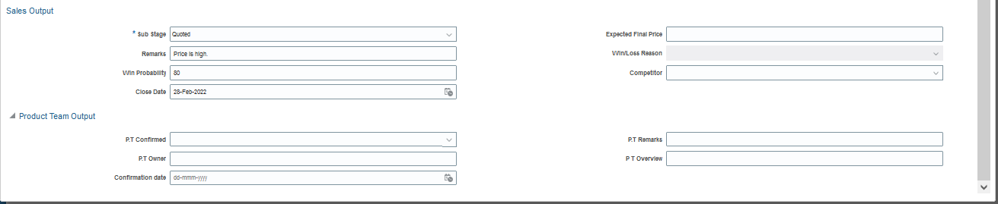

* **Understanding the Revenue Sub Stages**
* **CRM Update**: Not Quoted, Estimation, Quoted, Hot, LPO, LOI, Contract
* **Sales Update**: Pending Lost, Waiting, Not Applicable, With Others, Transferred

|  |  |
| --- | --- |
| CRM UPDATE | SALES UPDATE |
| **Not Quoted** –  default sub-stage upon opportunity creation | **Pending Lost** –  update this when you are not 100% sure yet that it is lost or lost still needs confirmation from customer and MKT |
| **Estimation** –  updated as per scope provided by sales in Estimation Request Form | **Waiting** –  update to this sub-stage when you are waiting for drawings, specs, waiting for MKT confirmation or information from customer |
| **Quoted** –  updated when we receive excel quotation or automatically by system if it is Oracle quotation | **Not Applicable** –  update if scope is NOT APPLICABLE for this project - sales remarks is MANDATORY |
| **Hot/LPO/LOI/Contract** –  updated accordingly by CRM team as per supporting document received from sales | **With Others** –  update if scope is with another contractor for this project – sales remarks MANDATORY with CONTRACTOR NAME  **Transferred** – this can be interchangeable with With Others (to be removed?) |

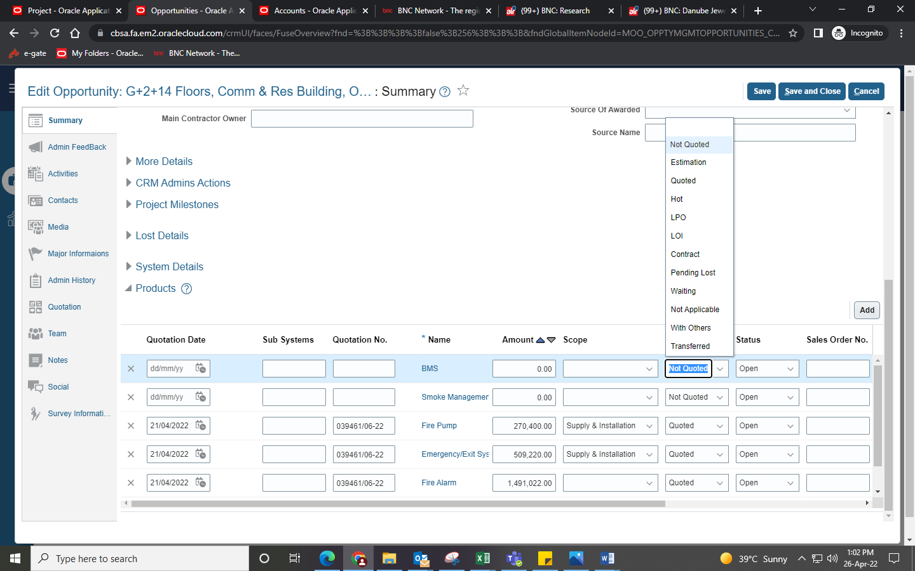

* **Understanding the Revenue Status**
* **CRM Update**: No Sale, Open, Won
* **Sales Update**: Lost

|  |
| --- |
| CRM UPDATE |
| **Open** –  Default status upon opportunity creation |
| **No Sale** –  Manually updated by CRM team as no sale only for 2 scenarios - when Sub Stage is ‘With Others’ or ‘Not Applicable’  Parameters required to update No Sale when Sub Stage is ‘With Others’:-   1. Opp ref. of other contractor (can be from FD/TME/Sec teams too) 2. If finalized before other contractor assigned to new salesman, then CRM remarks with MKT confirmation is valid to update With Others->No Sale   Parameters required to update No Sale when Sub Stage is ‘Not Applicable’:-   1. For SMS/BMS scope, PT Confirmation MANDATORY (should be CONFIRMED) 2. For FF/FP/FA/Em, MKT Confirmation MANDATORY (can add remarks of MKT in CRM Remarks section)   System automatically updates all revenue line status to ‘No Sale’ once opportunity is update as no sale. |
| **Won** –  All 3 parameters required to update this status:-   1. Sub-stage is LPO/LOI/Contract 2. Sales Order No. 3. Sales Order Date |

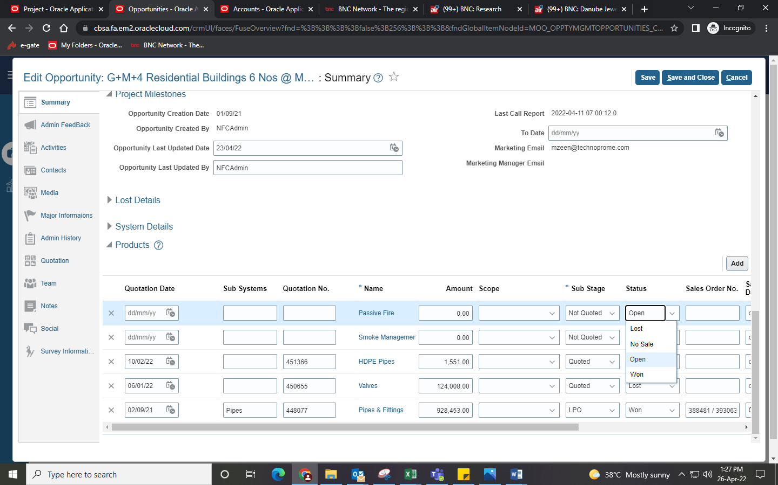

|  |
| --- |
| SALES UPDATE |
| **Lost –**  Only sales can update status to ‘Lost’ in the CRM.  Parameters required to update ‘Lost’ status:-   1. Competitor Name 2. Win/Loss Reason 3. Sales Remarks |

* **HOW TO - update Status to Lost**
* Add necessary parameters in ‘Lost Details’ section in the CRM (usually you need to press button to expand it)

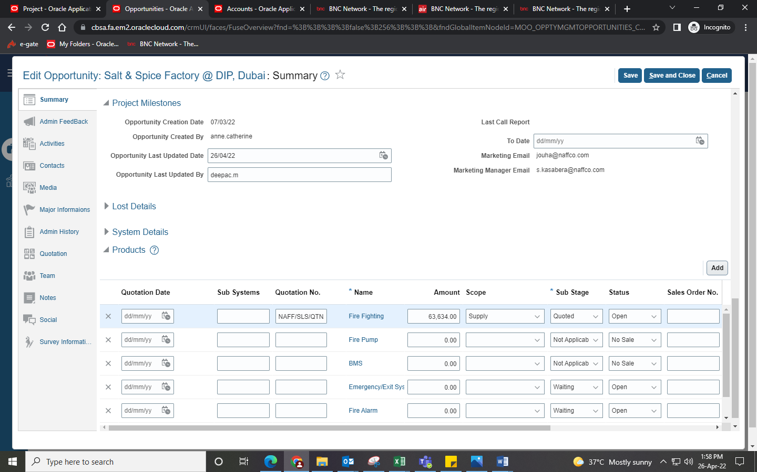

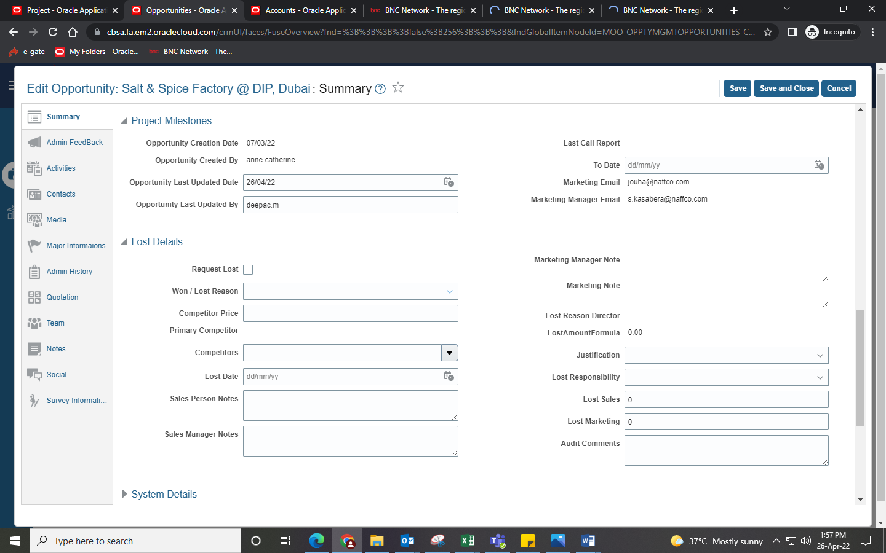

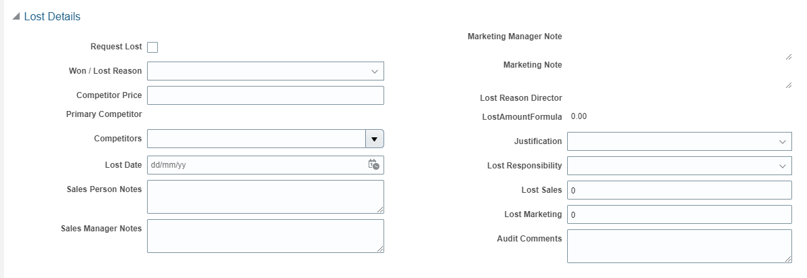

**Add sales remarks for further information**

**Add competitor name**

**Add win/loss reason**

* Then go in the Revenue Line and update the Status, Win/Loss Reason & Competitor drop-down options

**Select ‘Lost’ in drop-down**

**Select the same Win/Loss Reason & Competitor**

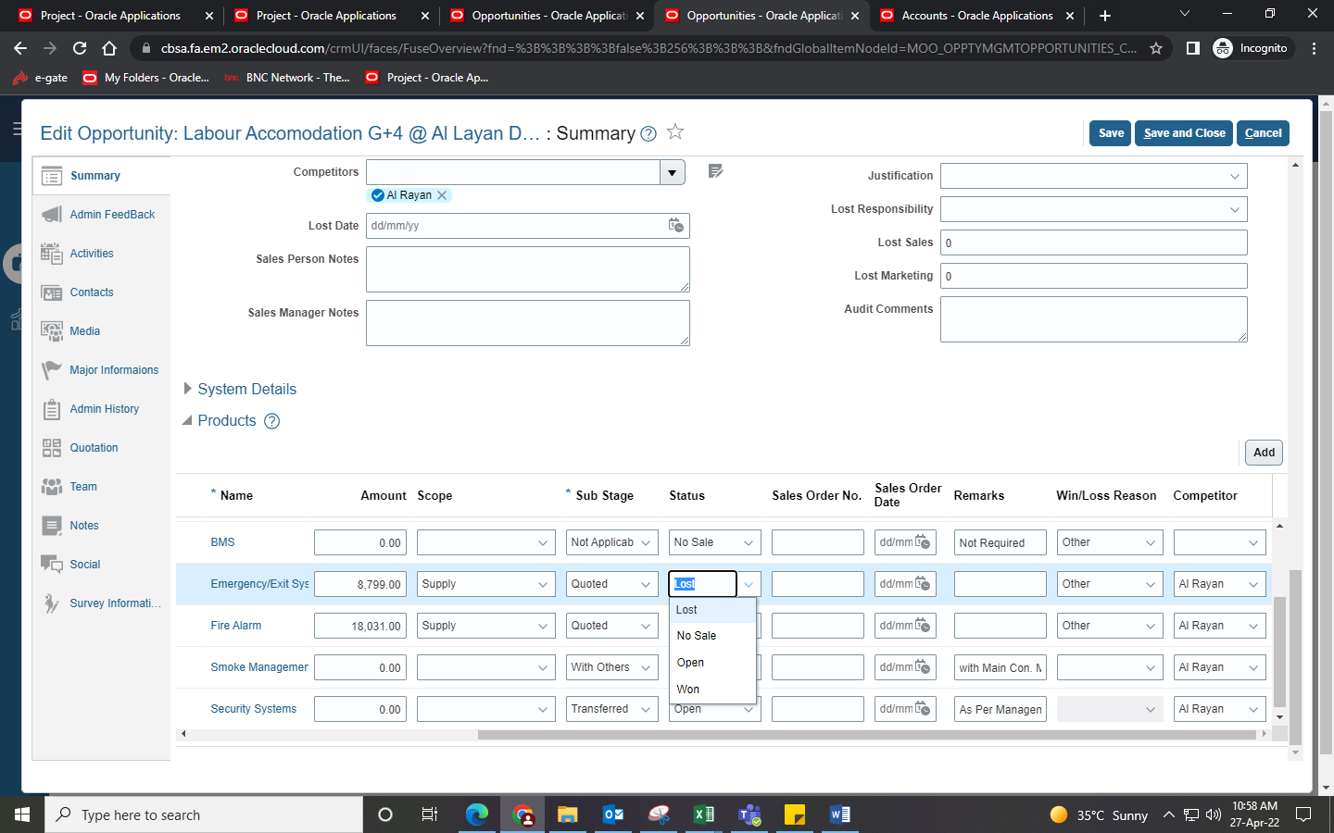

* **HOW TO - update revenue scope NOT APPLICABLE with remarks**

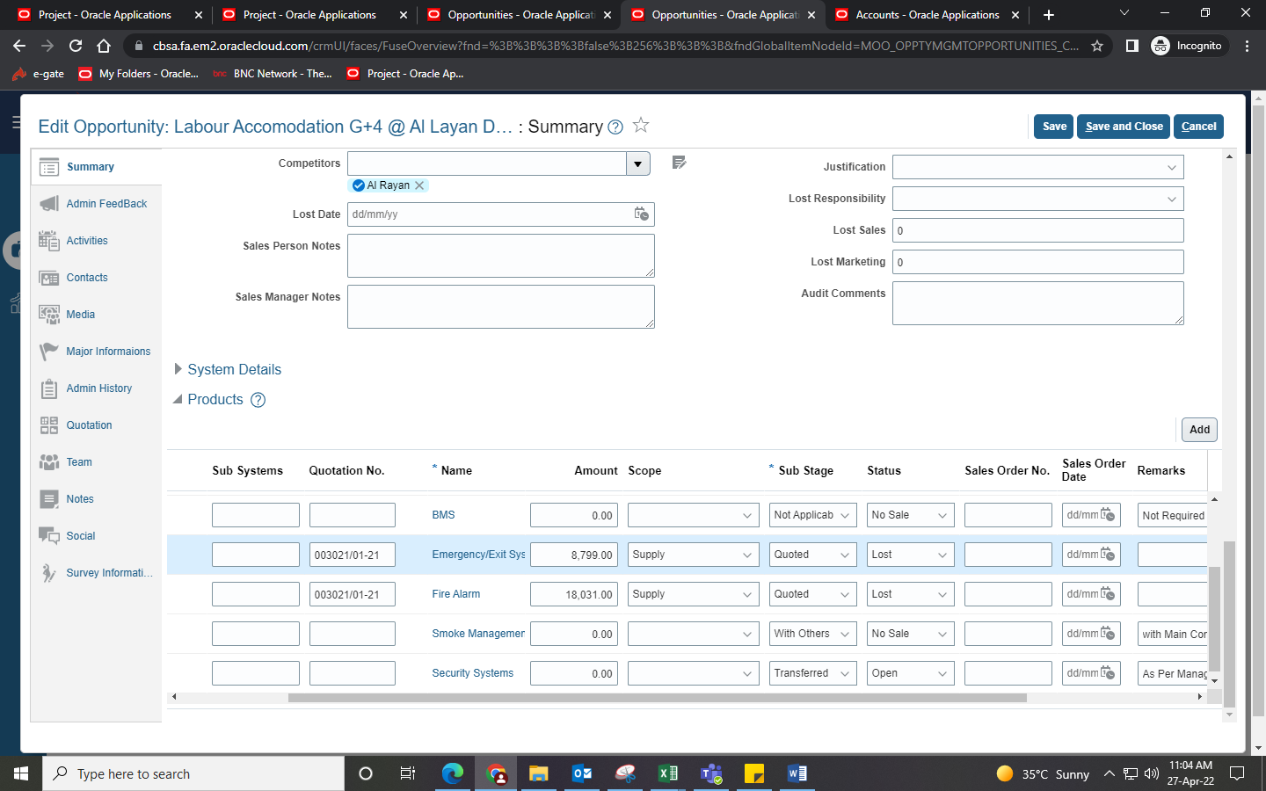

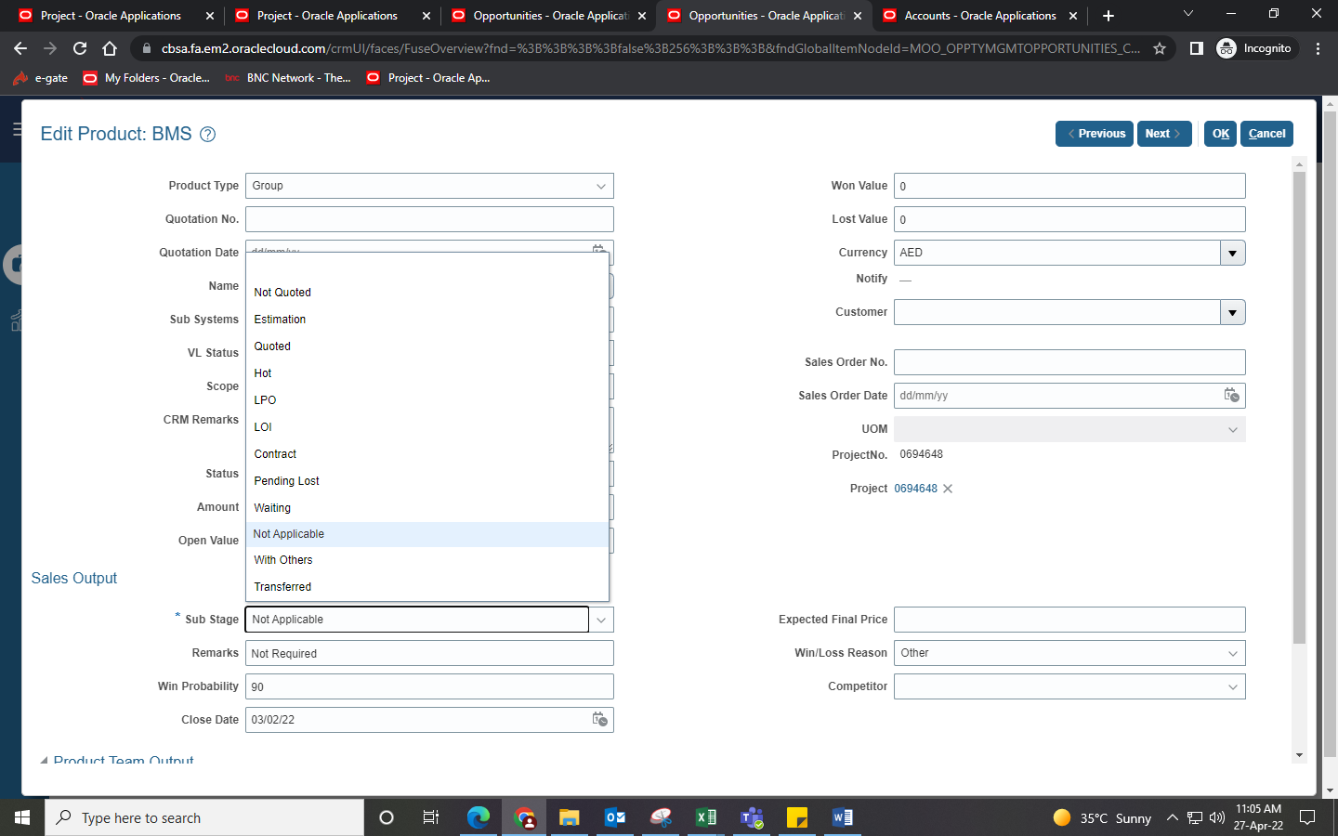

**Add your remarks - MANDATORY**

**Select ‘Not Applicable’ in drop-down**

* **HOW TO - update revenue scope With Others with remarks**



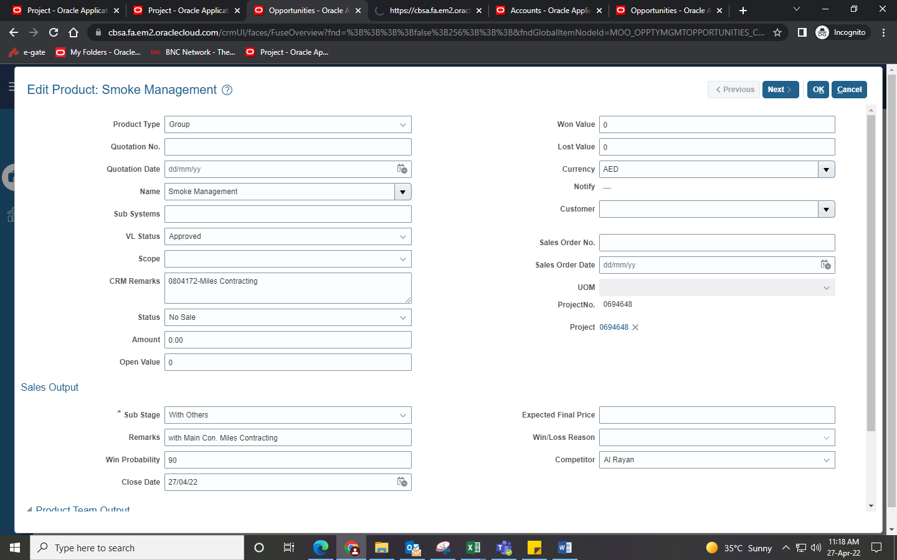

**Select ‘With Others’ in drop-down**

**Add your remarks - MANDATORY**